## **Week 6 Homework Submission File: Advanced Bash - Owning the System**

Please edit this file by adding the solution commands on the line below the prompt.

Save and submit the completed file for your homework submission.

**Step 1: Shadow People**

1. Create a secret user named sysd. Make sure this user doesn't have a home folder created: Your solution command here: **user --system --no-create-home sysd**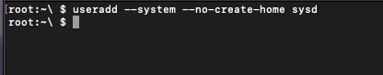
2. Give your secret user a password: Your solution command here: **passwd sysd**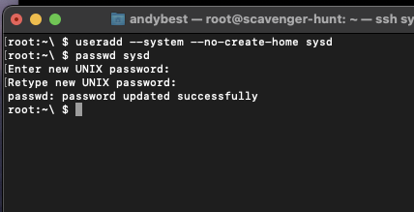
3. Give your secret user a system UID < 1000: Your solution here: **usermod -u 997 sysd**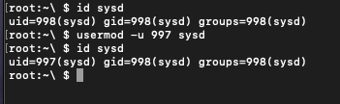
4. Give your secret user the same GID: Your solution here: **groupmod -g 997 sysd**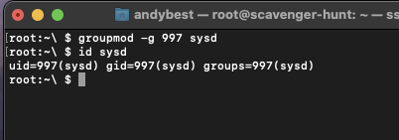
5. Give your secret user full sudo access without the need for a password:Your solution here: sysd **ALL=(ALL) NOPASSWD:ALL**

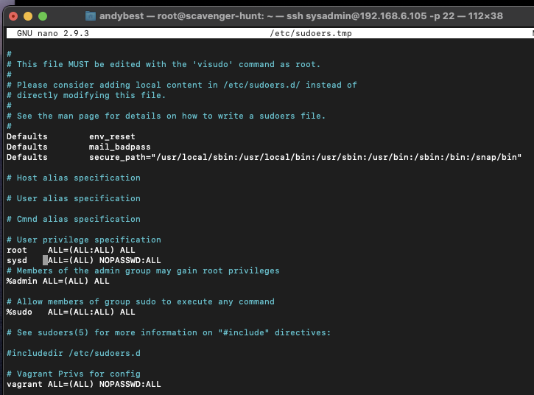

1. Test that sudo access works without your password:Your solution here: **su sysd**  
   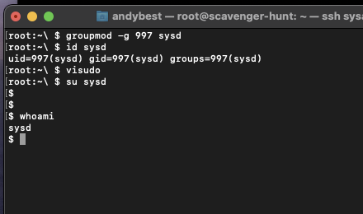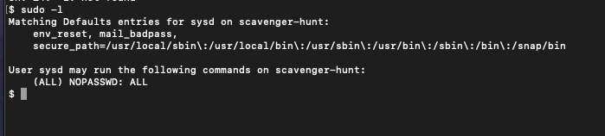

**Step 2: Smooth Sailing**

1. Edit the sshd_config file: Your solution here: **Port 2222**  
   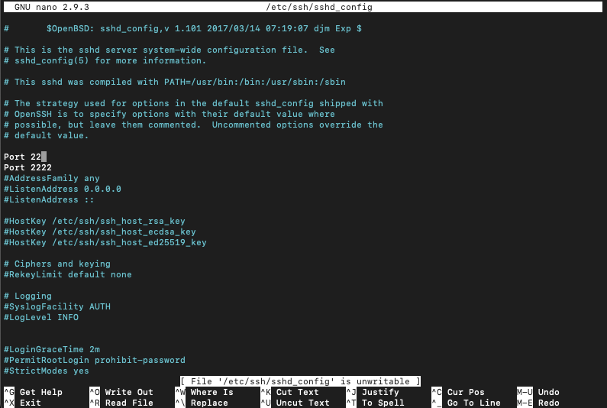

**Step 3: Testing Your Configuration Update**

1. Restart the SSH service: Your solution here: **sudo systemctl restart ssh**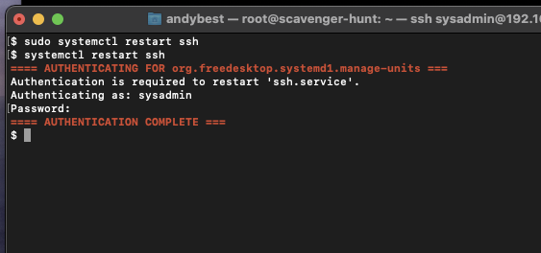
2. Exit the root account: Your solution here: **exit**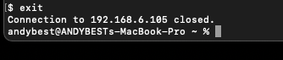
3. SSH to the target machine using your sysd account and port 2222: Your solution here: **ssh sys@192.168.6.105 -p 2222**

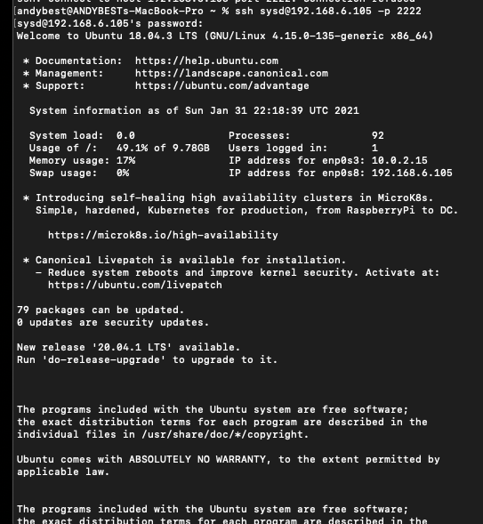

1. Use sudo to switch to the root user: Your solution here: **sudo su root**

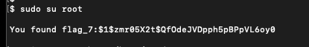

**Step 4: Crack All the Passwords**

1. SSH back to the system using your sysd account and port 2222: Your solution here: **ssh sysd@192.168.6.105 -p 2222** 
2. Escalate your privileges to the root user. Use John to crack the entire /etc/shadow file: Your solution here: **john /etc/shadow**

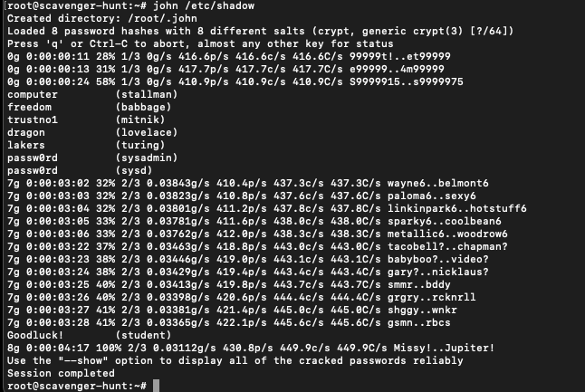

© 2020 Trilogy Education Services, a 2U, Inc. brand. All Rights Reserved.